Business Analyst Nano Degree (BAND)
Course 4: Power BI - Exercises
- Lesson 1: Design Principles for Effective Dashboards
  - Exercise 1: Creating Your First Report
    - The student will load a simple data set consisting of a single table of tech projects and activities. The table contains data showing the status of each project.
    - Tasks:
      - Load the Sample Projects CSV file into Power BI.
      - Set the canvas background to a light gray color.
      - Make a donut chart showing the number of tasks by owner by bringing [Task ID] to Values, and [Owner] to Legend.
      - Make a line graph showing the number of tasks that have to be started each month by bringing [Start Date] to X-axis, [Task ID] to Y-axis, and going down to the month-level of hierarchy using the forked down-arrow button located in the top-right corner of the graph.
      - Finally, let’s add a title, by inserting a text box with a clear background into the top left corner of the canvas. Title the report: Project Deliverables.
      - The final report should look like this:

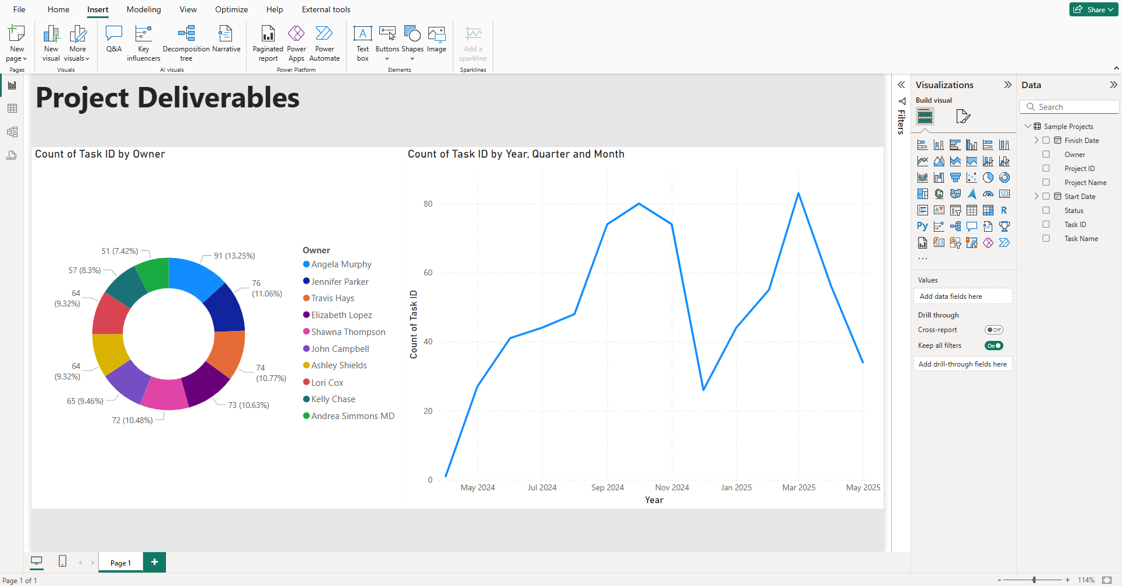

  - Exercise 2: Introducing Best Practice into a Report: Student will look at a report and provide guidance on how to improve it.
    - A Power BI report has been created using sample employee data. This company works in the tech space developing mobile apps. What’s wrong with this report? What would you change to make it better?
    - Tasks:
      - Open the Power BI report.
      - Make changes to the report so that the data reads clearly, the canvas is clean and easy to navigate, the correct graphs are chosen for the type of analysis indicated.
      - Power BI Report (Before):
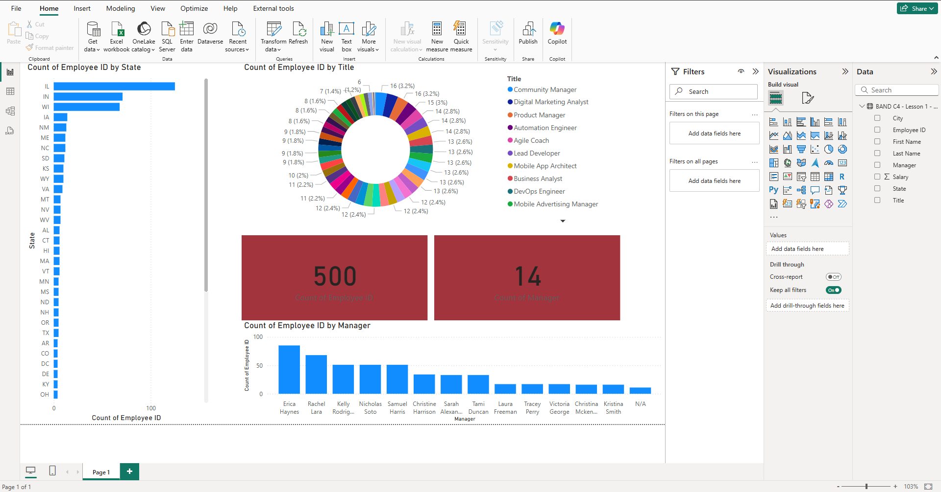

After applying changes, the report should look something like this:
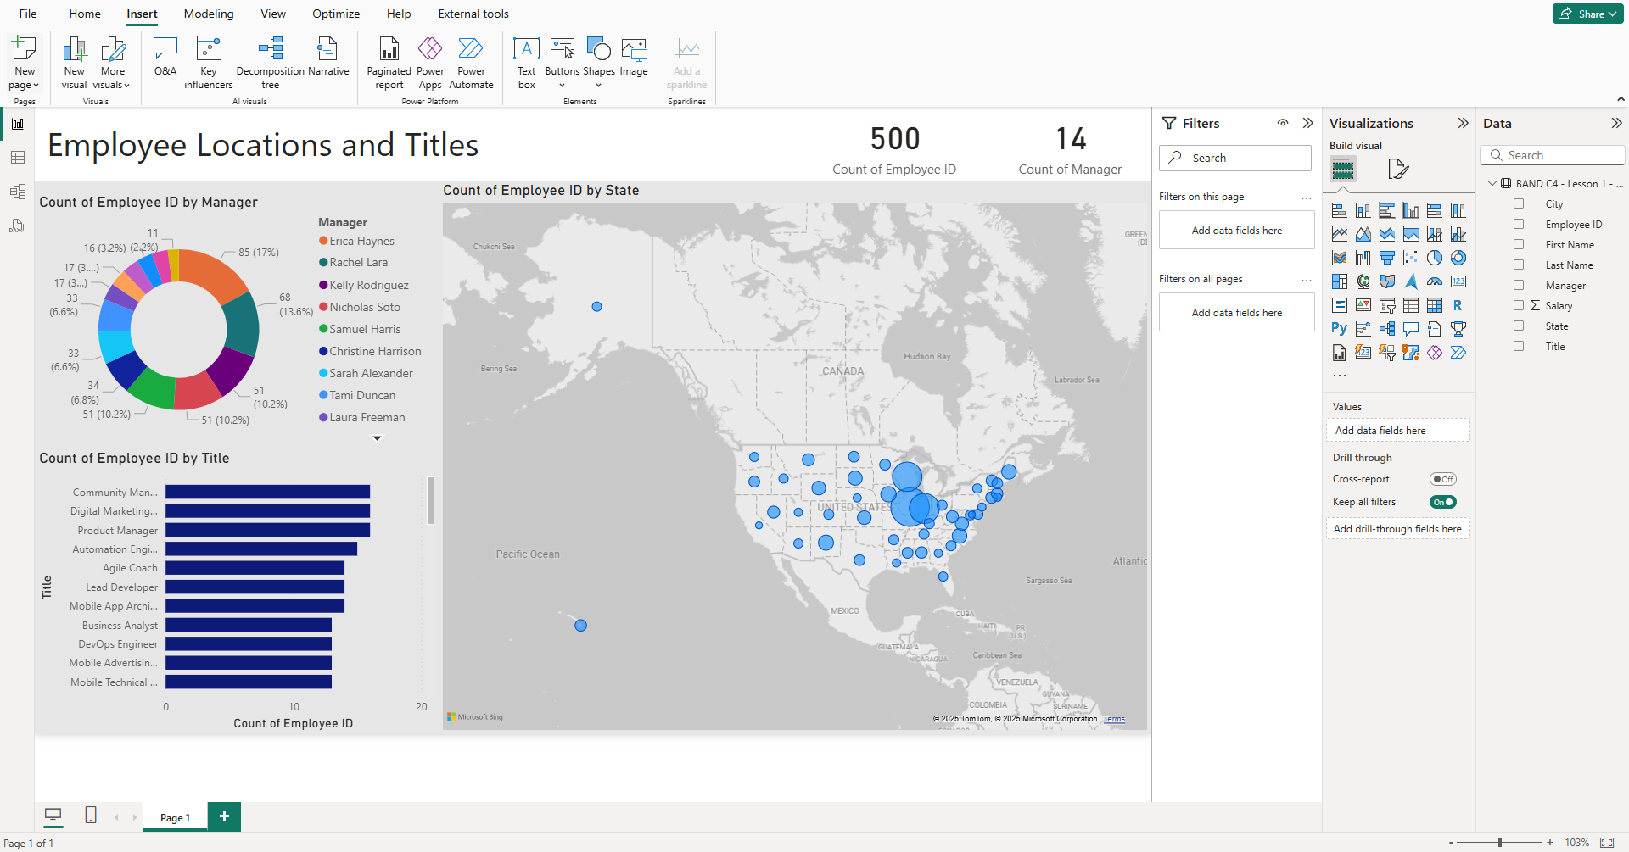

- Changes Made:
  - Canvas color changed to light gray
  - Bar chart changed to a grayscale map with a clear background
  - Cards moved to top, color removed, and font made smaller
  - Donut chart changed to a bar chart with dark blue bars and a clear background
  - Column chart changed to a bar chart with clear background
  - Title added (text box) to the top left: Employee Locations and Titles

- Lesson 2: Introductory Data Preparation in Power BI
  - Exercise 1: Ingest data and perform some basic cleanup steps to the data.
    - Load the Sample Employee Data – Errors CSV file. Fix the following data issues:
      - Duplicate Rows
      - Missing Data
      - Inconsistent Manager Names
      - Non-Atomic Employee Names
      - Incorrect Salary Data Type
      - Rename the Table/Query to “Employee_Data”
    - See the Power BI File “Employee Data – Errors Corrected” for the solution. In order to view the solution in Power Query, you’ll need to change the data source for the CSV file to load the CSV you saved to your machine.
  - Exercise 2: Writing your first DAX expressions.
    - Using the same Power BI file with employee data write DAX measures to answer the following questions:
      - Average employee salary
      - Lowest employee salary
      - Highest employee salary
      - Highest salary of an Automation Engineer
      - Average salary of Automation Engineers from Illinois (IL)
    - See the Power BI File “Employee Data – DAX Solutions” for the solution.
- Lesson 3: Working with Core Chart Types in Power BI
  - Exercise 1: Create a dashboard based on a set of requirements.
    - Work off your current employee data Power BI file to build a dashboard. To this file also load the Project Assignments and Sample Projects CSV files, then connect the tables together into a unified data model. Then build a dashboard adhering to the following requirements:
      - Cover Page: Visually engaging cover page with a background image, high-level KPI, and navigation buttons, and title.
      - Salary Page: Develop a page that can be used analyze employee salaries. Include:
        - Histogram: Bin Size = 20,000
        - Column Chart: Average Salary by Title
        - Donut: Number of Employees by Manager
        - Table: Listing of the employees with employee ID, first and last name, and salary.
  - Exercise 2: Dashboard Continued
      - Project Tracking: Develop a page that ties together employee data with the projects they’re assigned to:
        - Table: Show the Project Name, Owner, Start Date, Finish Date, and Status
        - Cards:
          - Number of Tasks
          - Number of Tasks Not Started
          - Number of Tasks In Progress
          - Number of Tasks Completed
  - Exercise 3: Add a Decomposition Tree
    - Add a Decomposition Tree visualization, and use the visualization to analyze employee data in a hierarchy.

- Lesson 4: Creating Interactive Dashboards
  - Exercise 1: Slicers and Filters
    - Working off your Employee Dashboard, make the following changes using the filters pane, and/or slicers:
      - Salary Page:
        - Filter the page to only show information for employees with “Engineer” in their title.
        - Add a searchable slicer to find employees by their last name.
        - Add a “Between” slicer to allow users to set the range of salaries on the page.
      - Project Tracking:
        - Filter the table to only show projects whose owner is: Angela Murphy, John Campbell, Kelly Chase, or TBD.
        - Add a card to show the number of delayed tasks, but rather than using a DAX formula, use a filter to arrive at the correct number.
  - Exercise 2: Putting it all together
    - Add a drill-through to allow a user to find an employee ID in the salary page and drill through to the project tracking page and see what projects their assigned to.
    - Add a clear all button to clear the drill-through on the Project Tracking page (you’ll need to create a bookmark).
    - Add a Map to a new page to visualize where all the employees are. You’ll need to create a calculated column to combine city, and state into a single column that can act as the location data for the map.
    - Add a Key Insights visualization to a new AI page to analyze Project List[Status] (target) by Project List [Owner].

